Members: Joshua Lioy

**CS 325 Implementation Assignment 3 Report**

Minimization of the Maximum Absolute Deviation:

1) Description of the LP:

2) Best solution to the specific problem given in the assignment description:  
a = 2.4286

b = 1.7143  
  
3) Output from MATLAB linprog solver:

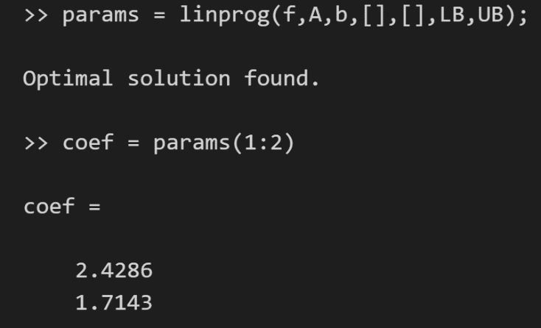

4) Plot of the instance points with the solution: 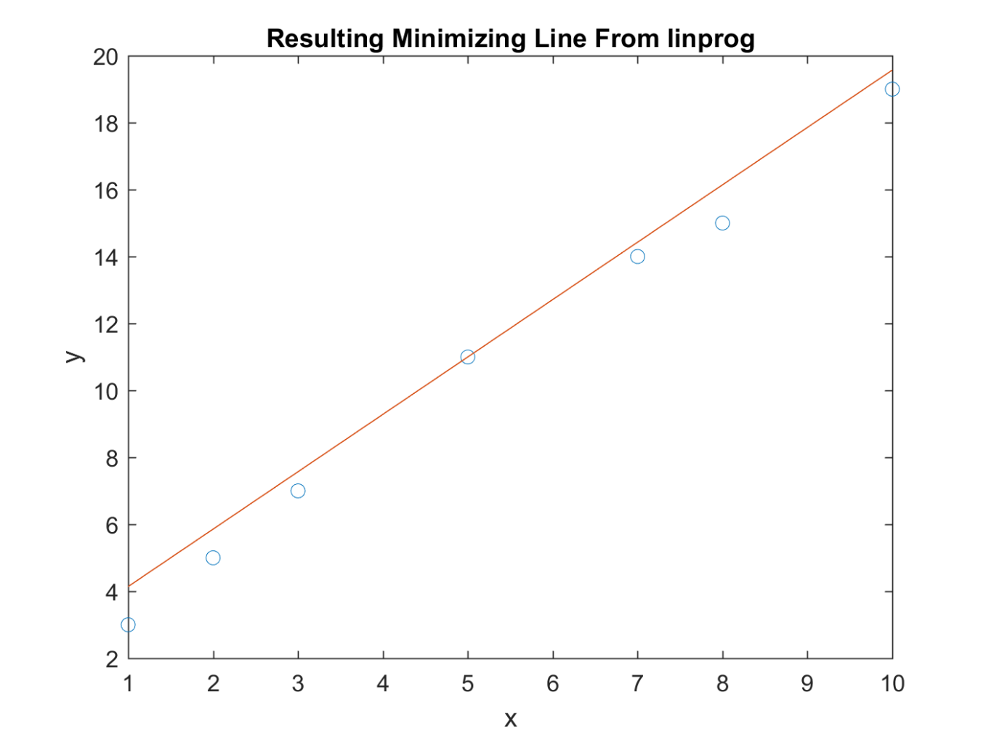

Note: Please see the MATLAB code included with the submission of this report for information on the setup of the data in preparation for the LP solver.  
  
Local Temperature Change

1. Description of the linear program: $$minimize \sum{T\left(d\right)} \\ subject to \\ -T\left(d\right)≤ x_{0}+ x_{1}d+ x_{2} ∙\cos\left(\frac{2πd}{365.25}\right)+ x_{3} ∙\sin\left(\frac{2πd}{365.25}\right)+ x_{4} ∙\cos\left(\frac{2πd}{365.25 ×10.7}\right)+ x_{5} ∙\sin\left(\frac{2πd}{365.25 ×10.7}\right)-{avg}_{d} \\ T\left(d\right)≥ x_{0}+ x_{1}d+ x_{2} ∙\cos\left(\frac{2πd}{365.25}\right)+ x_{3} ∙\sin\left(\frac{2πd}{365.25}\right)+ x_{4} ∙\cos\left(\frac{2πd}{365.25 ×10.7}\right)+ x_{5} ∙\sin\left(\frac{2πd}{365.25 ×10.7}\right)-{avg}_{d}$$